NEVER MISS A BEAT Kaiser Chiefs

What did you learn today? (I learned nothin')
What did you do today? (I did nothin')
What did you learn at school? (I didn't go)
Why didn't you go to school? (I don't know)

It's cool to know nothin' / It's cool to know nothin'

Television's on the blink (there's nothin' on it)
I really wanna really big coat (with words on it)
What do you want for tea? (I want crisps)
Why didn't you join the team? (I just didn't)

It's cool to know nothin' / It's cool to know nothin'

Take a look, take a look, take a look at the
Kids on the street
No they never miss a beat/ No they never miss a beat
Never miss a beat/ Never miss a beat-beat, beat-beat
Take a look at the kids on the street
No they never miss a beat/ No they never miss a beat
Never miss a beat/ Never miss a beat/ Never miss a beat
Never miss a beat

Here comes the referee (the light's flashin')
Best bit of the day (now that's livin')
Why don't you run away? (are you kiddin'?)
What is the golden rule? (you say nothin')

It's cool to know nothin'/ It's cool to know nothin'

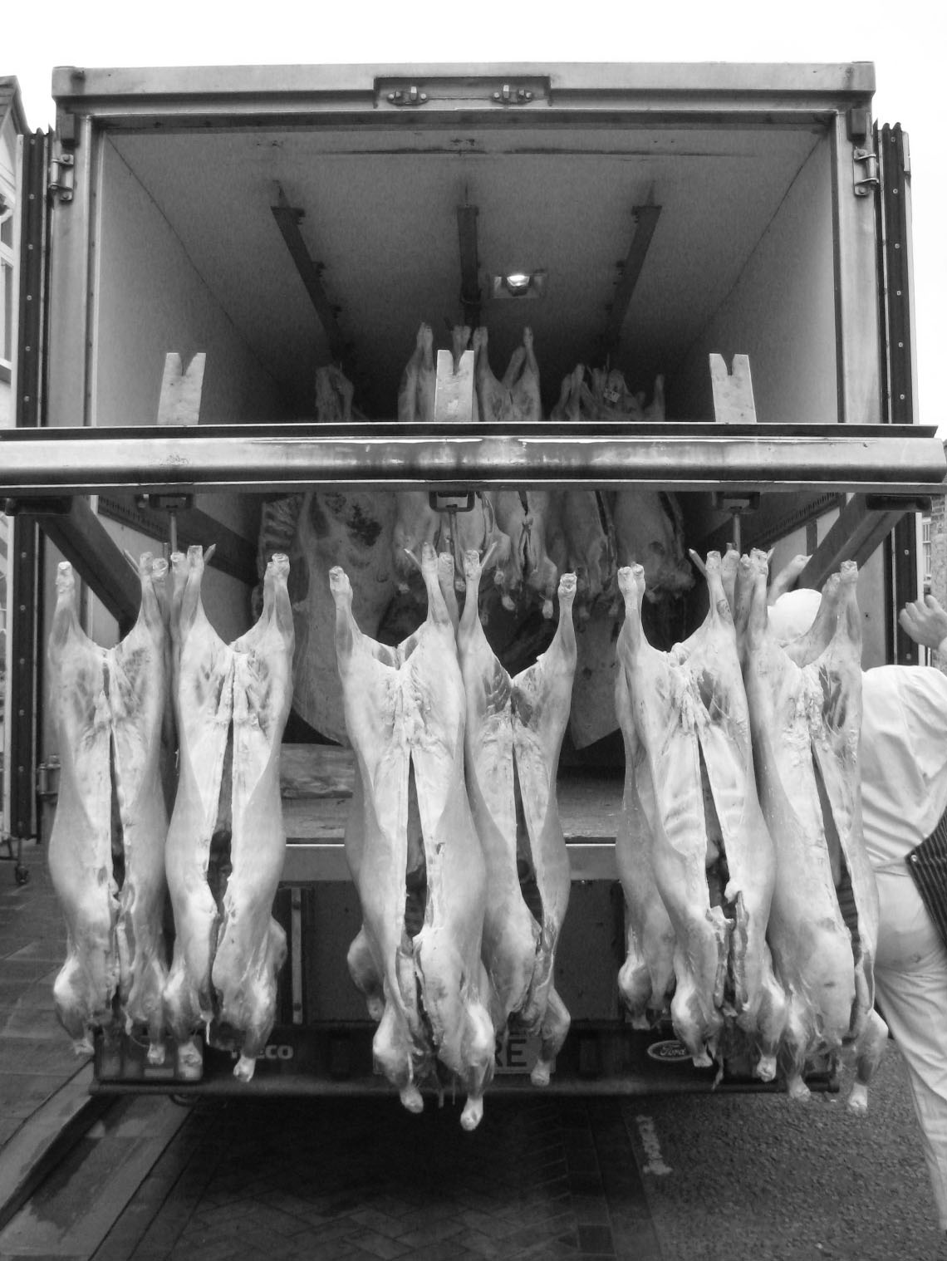

Take a look, take a look, take a look at the
Kids on the street
No they never miss a beat
No they never miss a beat
Never miss a beat
Never miss a beat-beat, beat-beat
Take a look at the kids on the street
No they never miss a beat
………………………Repeat…

“Never Miss A Beat” was the first single by Kaiser Chiefs from their third album ‘Off With Their Heads‘,
released on October 13 2008. [lyrics from http://lyrics.doheth.co.uk]

